<https://docs.atlassian.com/software/jira/docs/api/REST/7.6.1/#api/2/issue-updateComment>

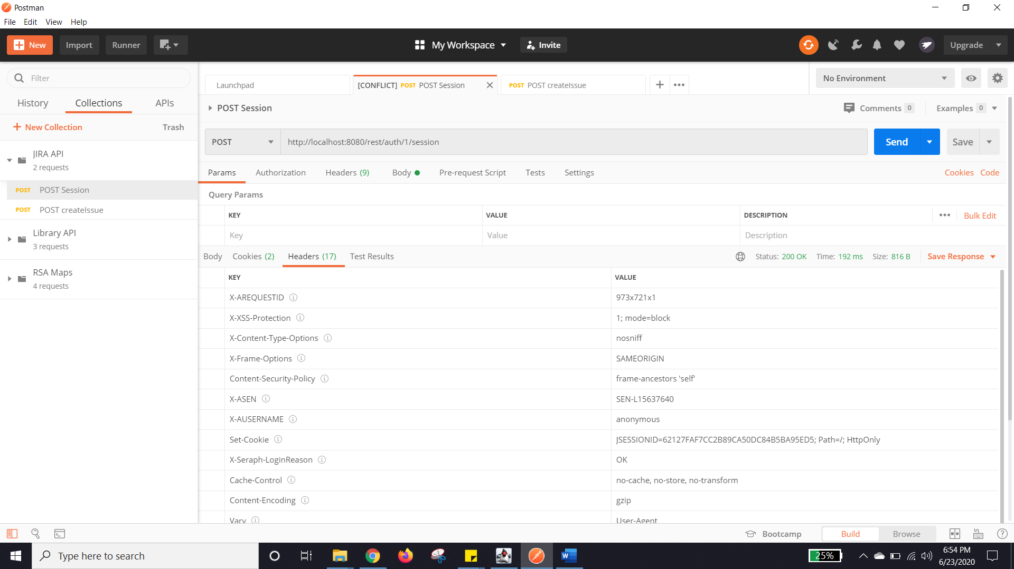

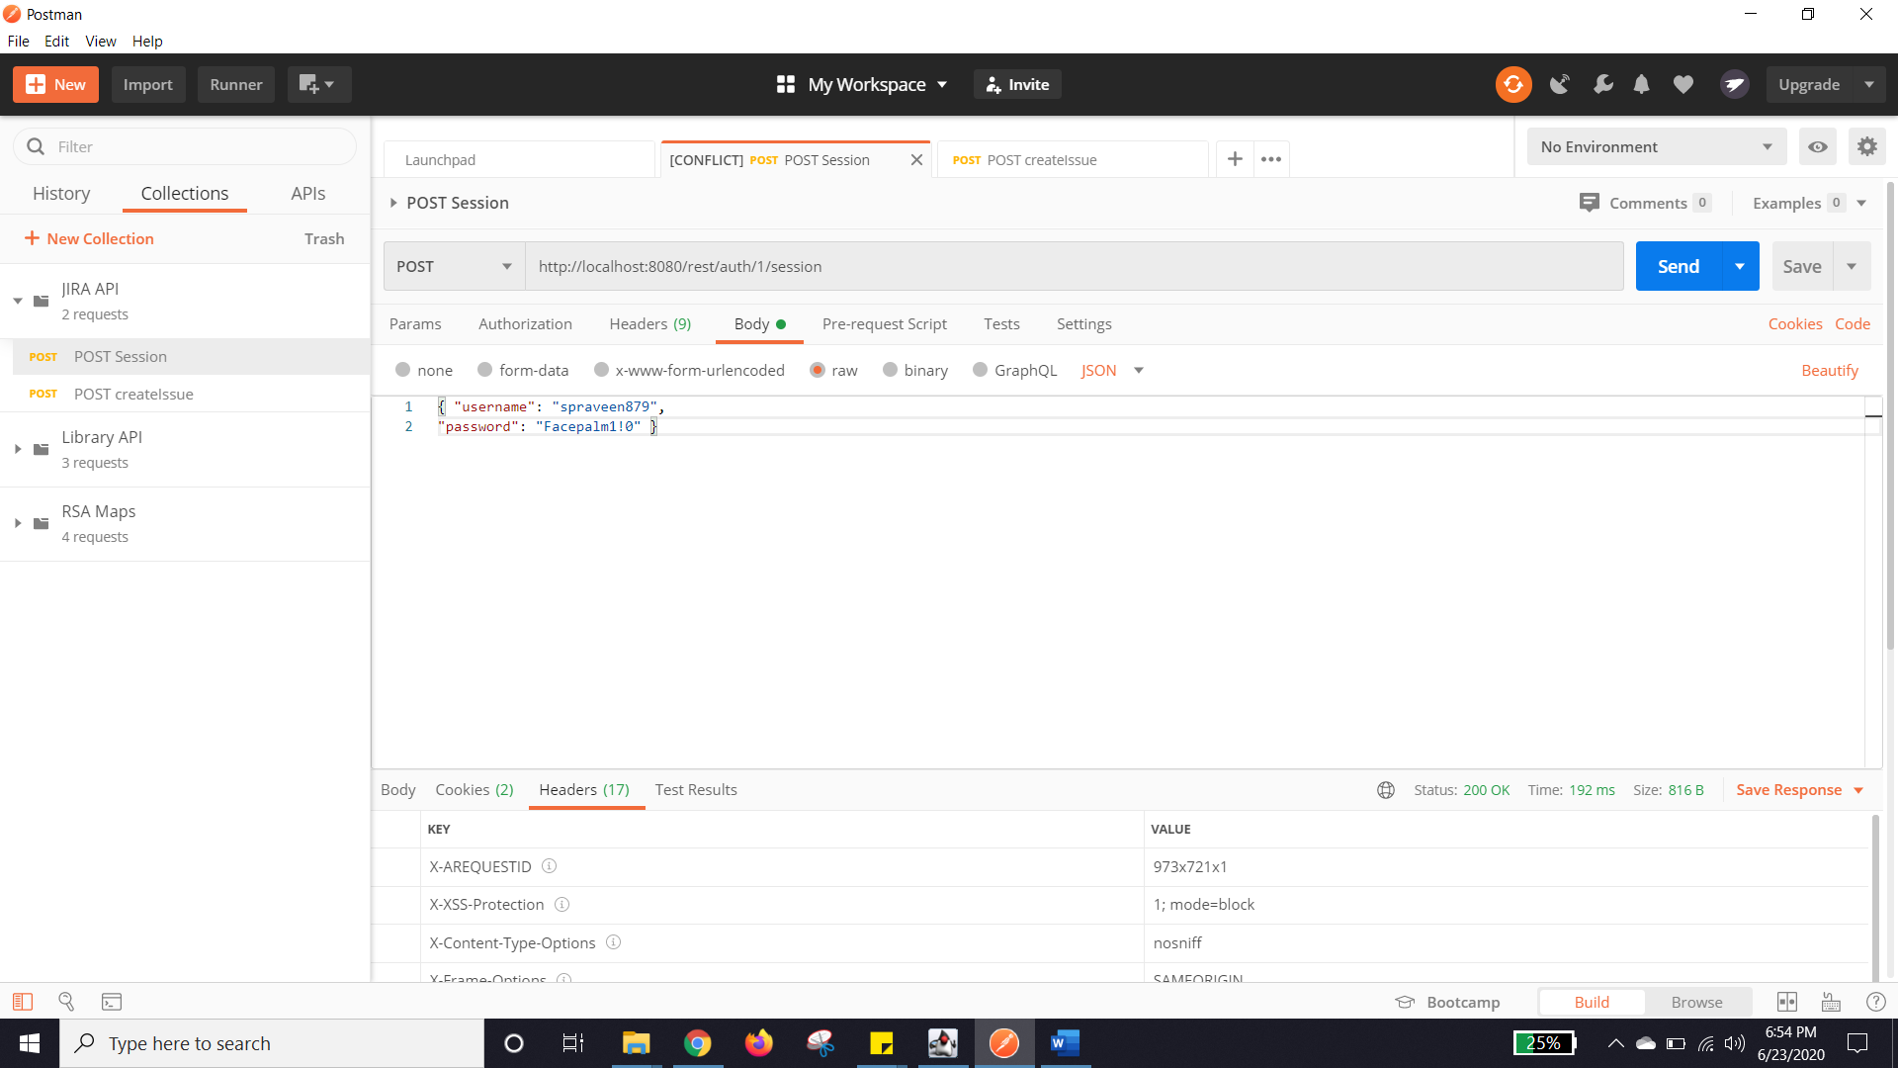

OUTPUT

